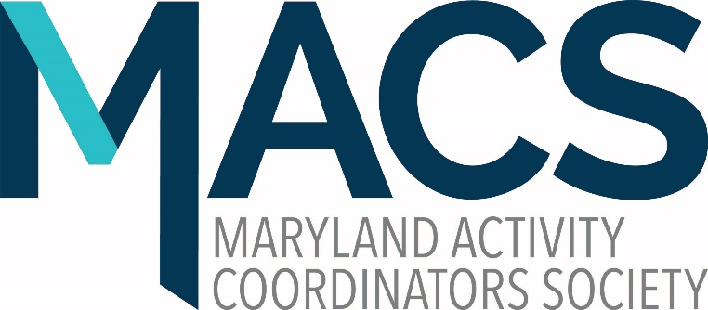
Dear Members of Maryland Activity Coordinators Society
We are accepting ballot nominations for members to the State Board of the Maryland Activity Coordinators Society. You may nominate yourself or another member. The board can provide training if interested in getting more involved. Officers and committee members must be members of MACS to serve in their roles.
Nomination for Officers for the year (October 1, 2023-September 30, 2024)
• President
_______________________________
_______________________________
• Vice President _______________________________
_______________________________
• Treasurer _______________________________
_______________________________
• Secretary
_________________________________
_________________________________
- Parlimentarian
_____________________________________
_____________________________________

(see page 2)

We also are looking for individuals who may want to get involved with committees or serve as a committee chair. We have multiple longstanding members who have retired and no longer can serve on the board. This has left us with open positions and a need for volunteer support.
Please check off those below you might be interested in.
- Social Media and Website
- By-Laws and Constitution
- Ways and Means (Spirit Wear and MACS items)
- Conference
- Webinars and Workshops
- NCCAP Representative
- NAAP Representative
- ATRA Representative
If checking more than one of these, please list your name and email address here:
_______________________________________________________________
Or if you wish ballot to remain anonymous, please email us at mdmacsinc@gmail.com to let us know which committees you are interested in.
Please submit your completed ballot to us no later than July 1, 2023 at:
Maryland Activity Coordinators Society
c/o Stacey Young
761 Hawthorne Rd.
Linthicum, MD 21090
Or email to: mdmacsinc@gmail.com

